E-Commerce Sales Analysis
Executive Summary
Objective
The objective of this analysis is to understand the factors driving revenue performance, identify high-performing products and customers, and uncover opportunities for business growth.

Key Findings
This analysis examined the performance of an e-commerce business using transactional sales data, focusing on revenue trends, customer behaviour, product performance, geographic distribution, and operational efficiency. The business generated approximately £8.9 million in revenue from 18,532 orders placed by 4,338 customers, with an average order value of £480.87 and an average customer spend of £2,054.27.

A clear seasonal pattern was identified, with revenue peaking between September and November, culminating in £1.16 million in November. Further investigation revealed that this growth was primarily driven by increases in both customer numbers and order volume rather than a significant increase in spending per order. Customer analysis showed that 65.6% of customers were repeat customers, indicating strong customer retention. Additionally, a small group of high-value customers contributed a substantial amount of revenue, with the top customer generating over £280,000 in sales.

Product analysis revealed that revenue was concentrated among a relatively small number of products. PAPER CRAFT, LITTLE BIRDIE was the highest revenue-generating product, producing £168,469.60 in revenue and ranking among the highest-selling products by quantity, suggesting strong customer demand. Geographic analysis demonstrated a heavy reliance on the United Kingdom, which generated over £7.3 million in revenue and accounted for most orders. While international markets contributed additional revenue, their impact was significantly smaller compared to the domestic market.

Finally, operational analysis identified a notable level of order cancellations, highlighting an opportunity to further investigate operational processes and customer purchasing behaviour. Based on these findings, key recommendations include improving inventory and marketing preparation ahead of peak seasonal demand, strengthening customer retention initiatives, and exploring growth opportunities in international markets to reduce dependence on the UK market.

1. Data Overview
Dataset Description
This dataset contains 541,909 transactional records from a UK‑based, non‑store online retailer, covering the period 01/12/2010 to 09/12/2011. It is a multivariate, sequential, time‑series dataset commonly used for business analytics and customer behaviour modelling.
The retailer primarily sells unique, all‑occasion gift products, and a significant portion of its customers are wholesalers. Each transaction includes details such as invoice number, product code, description, quantity, invoice timestamp, unit price, customer ID, and customer country. Dataset Information

Number of records: 541,909
Date range: 01/12/2010 - 09/12/2011
Number of countries: 38
Number of products: 4067
Number of customers: 4372
Key columns:
Column | Description
InvoiceNo | This is a 6-digit code used to identify each order.
StockCode | This is a VARCHAR code to identify stock.
Description | This contains the name of the products.
Quantity | This contains the number of products.
InvoiceDate | This is the date of the transaction.
UnitPrice | This contains the price of the product.
CustomerID | Each customer is assigned a unique ID.
Country | This is the transaction location.

2. Data Quality Assessment
Is the dataset suitable for analysis?
This is suitable for analysis because it’s a data set with over 500,000 records spanning approximately 1 year. This data includes useful factors such as customer, product, transactions and geographic information. Furthermore, missing and invalid records represent a manageable proportion of the dataset.

Data Quality Checks:
- Missing Customer IDs
Finding: while looking through the data in excel, I noticed that some fields in the customed id column are empty and I believe these fields should be excluded rather than deleted using exclusion queries.
- Cancelled Orders
Finding: Cancelled orders are not beneficial in answering insights into how the business operates now, but I won’t delete it because it might be useful further on.
- Bad Debt Adjustments
Finding: This is not useful either now but will be left in the dataset but still excluded.
- Zero or Negative Prices
Finding: In the dataset, there are over 2000 rows with unit price equal to or less than 0 and these are excluded as well.
Data Cleaning Decisions
Issue | Action Taken | Reason
Missing Customer IDs | Excluded from analysis | Missing customer IDs prevent accurate customer-level analysis such as identifying repeat customers, calculating customer lifetime value, or measuring customer retention.
Cancelled Orders | Excluded from analysis | Cancelled orders do not represent completed sales and therefore were excluded from revenue calculations. However, they may provide useful operational insights and were retained in the raw dataset.
Bad Debt Adjustments | Excluded from analysis | Not enough data of this and thus not relevant.
Invalid Prices | Excluded from analysis | Not useful in sales analysis.

Conclusion
Although several data quality issues were identified, they affected a relatively small proportion of the dataset and could be addressed through query-level filtering. The remaining data is suitable for reliable sales, customer and product analysis.

3. Sales Performance Analysis
How is the business performing overall?
- Total Revenue
Finding: £8.9 million
- Total Orders
Finding: 18,532 orders
- Total Customers
Finding: 4,338 customers
- Average Order Value
Finding: £480.87
Interpretation
The business generated £8.9 million in revenue from 18,532 orders placed by 4,338 customers. The average order value of £480.87 indicates that each transaction generates a substantial amount of revenue. This may reflect the wholesale nature of many purchases, where customers buy multiple items in a single order.

Does revenue vary throughout the year?
- Revenue by Month
Finding: Revenue fluctuated throughout 2011, with the strongest performance occurring between September and November. November generated the highest monthly revenue (£1.16 million), followed by October (£1.04 million) and September (£952,838). Revenue remained relatively stable during the first eight months of the year before increasing sharply in the final quarter.
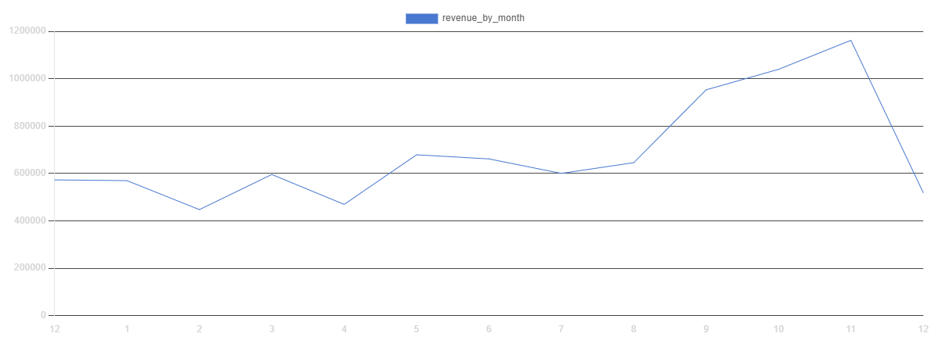
- Orders by Month
Finding: The number of orders remained relatively stable throughout most of 2011 before increasing significantly during September, October and November. November recorded the highest order volume with 2,657 orders, compared with 1,280 orders in August. The increase in revenue observed during the final quarter of the year coincided with a substantial increase in order volume. This suggests that higher revenue was at least partially driven by customers placing more orders rather than solely by increased spending per transaction.
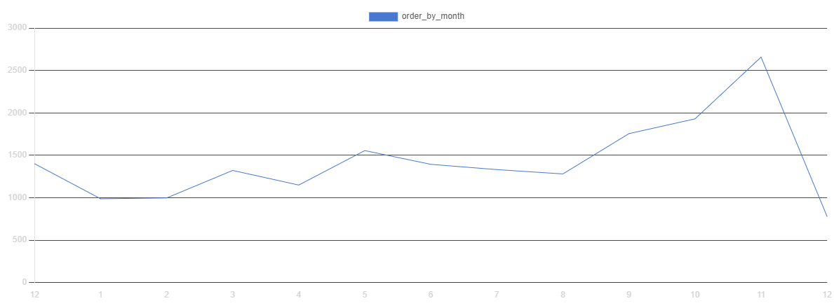
- Customers by Month
Finding: The number of unique customers increased substantially during the final quarter of 2011. Customer count rose from 935 in August to 1,664 in November, representing the highest level observed during the analysis period.
The increase in customer numbers coincided with the growth in both revenue and order volume during September–November. This suggests that the strong performance during this period was partially driven by a larger number of customers making purchases.
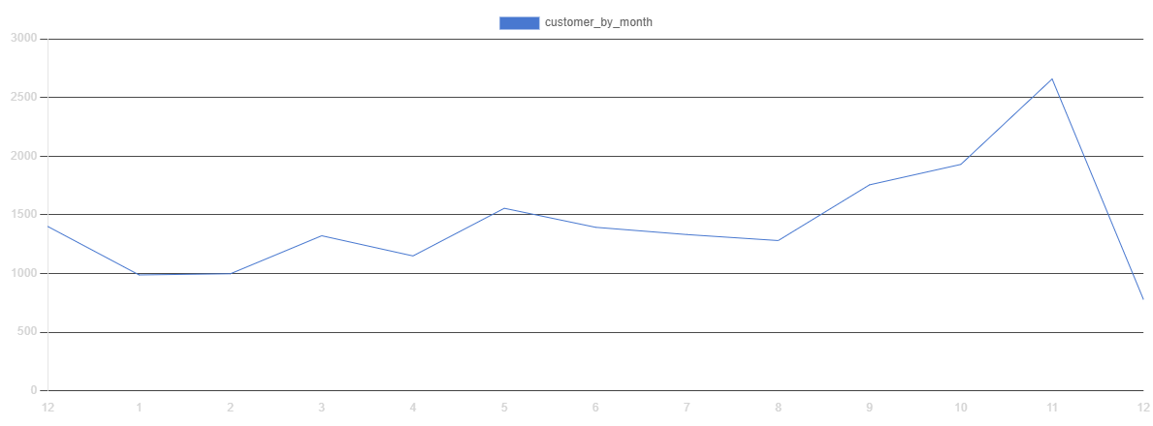
- Average Order Value by Month
Finding: Average Order Value remained relatively stable throughout most of the year, ranging between approximately £436 and £576. Although AOV increased slightly during September and October, it declined to £437.27 in November despite November generating the highest monthly revenue. The increase in revenue during September–November does not appear to have been primarily driven by customers spending significantly more per order. Instead, the higher revenue coincided with substantial increases in both customer numbers and order volume.
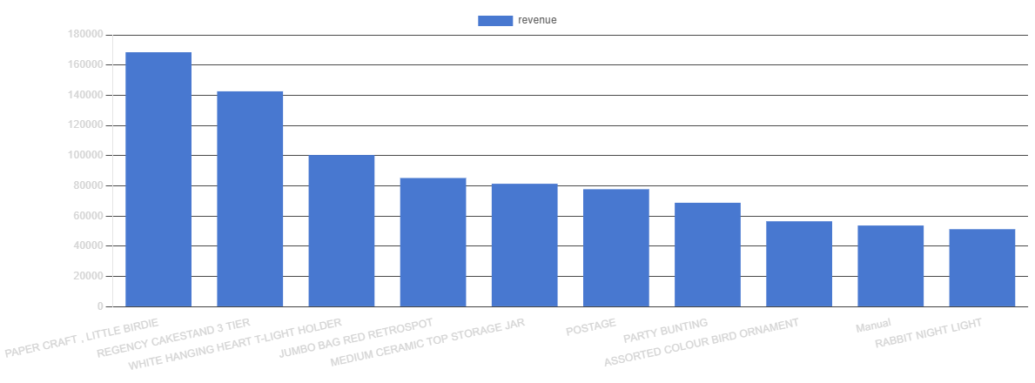

Business Insight:
Revenue displayed a clear seasonal pattern, with September–November representing the strongest trading period. Further investigation revealed that this increase was largely driven by higher customer participation and greater order volume rather than a significant increase in average spending per transaction.

4. Product Performance Analysis
Business Question - Which products generate the most revenue?
Top 10 Products by Revenue
Rank | Product | Revenue
1 | PAPER CRAFT , LITTLE BIRDIE | 168469.6
2 | REGENCY CAKESTAND 3 TIER | 142593
3 | WHITE HANGING HEART T-LIGHT HOLDER | 100448.2
3 | JUMBO BAG RED RETROSPOT | 85220.78
4 | MEDIUM CERAMIC TOP STORAGE JAR | 81416.73
5 | POSTAGE | 77803.96
6 | PARTY BUNTING | 68844.33
7 | ASSORTED COLOUR BIRD ORNAMENT | 56580.34
8 | Manual | 53779.93
9 | RABBIT NIGHT LIGHT | 51346.2
10 | CHILLI LIGHTS | 46286.51


Findings: The highest revenue-generating product was PAPER CRAFT, LITTLE BIRDIE, generating £168,469.60 in revenue. Other top-performing products included products such as REGENCY CAKESTAND 3 TIER, WHITE HANGING HEART T-LIGHT HOLDER, and MEDIUM CERAMIC TOP STORAGE JAR. Revenue among the top 10 products ranged from approximately £51,000 to £168,000, indicating that a relatively small group of products contributed substantially to overall sales revenue.
Interpretation: The presence of PAPER CRAFT, LITTLE BIRDIE as both a top revenue product and a top-selling product by quantity suggests that its performance was driven by strong customer demand rather than high pricing alone. More broadly, the gap between the highest- and lowest-ranked products in the top 10 indicates that revenue is concentrated among a small number of key products. These products likely represent important drivers of the business's sales performance and should be monitored closely for inventory planning and promotional opportunities.

Which products are the most popular?
Top 10 Products by Quantity Sold
Rank | Product | Quantity Sold
1 | PAPER CRAFT, LITTLE BIRDIE | 80995
2 | MEDIUM CERAMIC TOP STORAGE JAR | 77916
3 | WORLD WAR 2 GLIDERS ASSTD DESIGNS | 54415
4 | JUMBO BAG RED RETROSPOT | 46181
5 | WHITE HANGING HEART T-LIGHT HOLDER | 36725
6 | ASSORTED COLOUR BIRD ORNAMENT | 35362
7 | PACK OF 72 RETROSPOT CAKE CASES | 33693
8 | POPCORN HOLDER | 30931
9 | RABBIT NIGHT LIGHT | 27202
10 | MINI PAINT SET VINTAGE | 26076

Findings: The highest-selling products by quantity were led by PAPER CRAFT, LITTLE BIRDIE, followed by several decorative and household products. The ranking shares similarities with the top revenue products, suggesting that certain products generate revenue through high sales volume rather than premium pricing.

Interpretation: Products appearing in both the revenue and quantity rankings can be considered core products within the catalogue, as they contribute significantly to both sales volume and revenue generation.

Which products perform poorly?
Lowest Revenue Products:
Rank | Product | Lowest revenue
1 | PADS TO MATCH ALL CUSHIONS | 0
2 | HEN HOUSE W CHICK IN NEST | 0.42
3 | SET 12 COLOURING PENCILS DOILEY | 0.65
4 | VINTAGE BLUE TINSEL REEL | 0.84
5 | PINK CRYSTAL GUITAR PHONE CHARM | 0.85
6 | PURPLE FRANGIPANI HAIRCLIP | 0.85
7 | CAT WITH SUNGLASSES BLANK CARD | 0.95
8 | HAPPY BIRTHDAY CARD TEDDY/CAKE | 0.95
9 | 60 GOLD AND SILVER FAIRY CAKE CASES | 1.1
10 | RUBY GLASS CLUSTER EARRINGS | 1.25

Finding: The lowest revenue-generating products produced less than £2 in total revenue during the analysis period. Several products generated under £1 in revenue, with PADS TO MATCH ALL CUSHIONS generating no revenue at all.
Lowest Quantity Sold Products:
Rank | Product | Lowest product
1 | MARIE ANTOIENETT TRINKET BOX GOLD | 1
2 | BLACKCHRISTMAS TREE 30CM | 1
3 | PURPLE CHUNKY GLASS+BEAD NECKLACE | 1
4 | BLUE/GREEN SHELL NECKLACE W PENDANT | 1
5 | NECKLACE+BRACELET SET PINK DAISY | 1
6 | BLACK VINT ART DEC CRYSTAL BRACELET | 1
7 | SET 10 CARDS HANGING BAUBLES 17080 | 1
8 | HEN HOUSE W CHICK IN NEST | 1
9 | PINK POLKADOT KIDS BAG | 1
10 | LASER CUT MULTI STRAND NECKLACE | 1

Finding: Several products recorded only a single unit sold during the analysis period, including MARIE ANTOIENETT TRINKET BOX GOLD, BLACK CHRISTMAS TREE 30CM, and various jewellery and gift products.
Interpretation: Products appearing in both the lowest revenue and lowest quantity rankings, such as HEN HOUSE W CHICK IN NEST, experienced both low customer demand and minimal sales contribution. These products had little impact on overall business performance compared with the top-selling products.
The results also suggest that revenue is concentrated among a relatively small number of products, while many products contribute only marginally to total sales. This is common in retail businesses where a small group of products often generates a large share of revenue.

5. Customer Analysis
Who are the most valuable customers?
Investigation
Top Customers by Revenue
Rank | CustomerID | Revenue
1 | 14646 | £280,206.02
2 | 18102 | £259,657.30
3 | 17450 | £194,550.79
Findings: The highest revenue-generating customer was Customer 14646, contributing £280,206.02 in revenue. The top three customers each generated more than £190,000 in revenue, significantly exceeding the spending levels of the average customer.
Interpretation: The business appears to rely on a small group of high-value customers who contribute a substantial amount of revenue. These customers are likely important accounts and may represent wholesale buyers or customers with frequent purchasing activity.
Identifying and retaining these high-value customers could have a significant impact on future revenue. The findings suggest that customer relationship management and retention strategies should prioritize these customers, as losing even one could result in a noticeable reduction in sales.

Are customers returning to make additional purchases?
One-Time vs Repeat Customers
Customer Type | Count
One-Time | 1493
Repeat | 2845

Findings: Out of 4,338 customers, 2,845 (65.6%) were repeat customers, while 1,493 (34.4%) made only a single purchase during the analysis period.
Interpretation: Most customers returned to make additional purchases, indicating a strong level of customer retention. With nearly two-thirds of customers placing more than one order, the business appears to benefit from a loyal customer base rather than relying solely on acquiring new customers.
The high proportion of repeat customers suggests that customer retention plays an important role in overall revenue generation and may be a key driver of long-term business performance.

How much does the average customer spend?
Average Customer Spend | £2054.27

Finding: The average customer spent £2,054.27 during the analysis period. This indicates that, on average, each customer contributed over £2,000 in revenue to the business.

Interpretation: The relatively high average customer spend suggests that customers typically make substantial purchases, which is consistent with the wholesale nature of the business. Combined with the finding that 65.6% of customers were repeat customers, this indicates that revenue is not solely driven by one-off purchases but also by customers returning to make additional transactions.
However, average values can be influenced by a small number of very high-spending customers. The presence of customers generating over £190,000 in revenue suggests that spending may be unevenly distributed across the customer base, with a small group of customers contributing a disproportionately large share of total revenue.

6. Geographic Analysis
Which countries generate the most revenue?
Revenue by Country
Rank | Country | Revenue
1 | United Kingdom | £7308391.55
2 | Netherlands | £285446.34
3 | EIRE | £265545.90
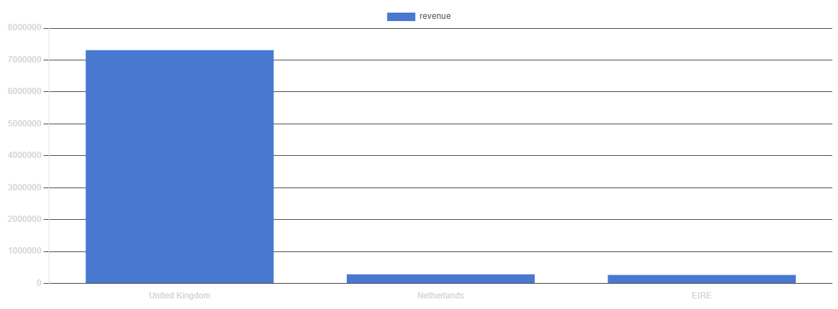
Findings: The United Kingdom generated the highest revenue by a substantial margin, contributing £7.31 million in sales. The Netherlands (£285,446) and EIRE (£265,546) ranked second and third respectively, although their revenues were significantly lower than the United Kingdom's.
Interpretation: The business is heavily reliant on the United Kingdom market, which accounts for most of the total revenue. While international markets such as the Netherlands and EIRE contribute meaningful revenue, their impact is relatively small compared with the domestic market. This suggests that the United Kingdom is the company's core market and primary source of business performance.
The results also indicate opportunities for growth in international markets. If the company can replicate its success in countries such as the Netherlands, Germany, and France, it may be able to diversify revenue sources and reduce reliance on a single market.

Which countries place the most orders?
Orders by Country
Rank | Country | Orders
1 | United Kingdom | 16646
2 | Germany | 457
3 | France | 389
Findings: The United Kingdom recorded the highest number of orders with 16,646 orders, significantly exceeding all other countries. Germany (457 orders) and France (389 orders) ranked second and third respectively.
Interpretation: The high order volume from the United Kingdom aligns with its position as the largest revenue-generating country, indicating that strong financial performance is driven by both a large customer base and a high number of transactions. The substantial gap between the United Kingdom and other countries suggests that customer demand is heavily concentrated in the domestic market.
Interestingly, the countries generating the most revenue are not identical to those placing the most orders. For example, the Netherlands ranks second in revenue but does not appear in the top three for orders. This may indicate that Dutch customers place larger orders on average, resulting in higher revenue despite fewer transactions. This could be investigated further through an analysis of Average Order Value by Country.

7. Operational Analysis
How significant are cancellations?

Cancellation Rate
The business recorded 3,654 cancelled orders, representing approximately 19.7% of all orders during the analysis period.

Cancelled Orders by Country:
Rank | Country | Cancelled Orders
1 | United Kingdom | 3,208
2 | Germany | 146
3 | France | 69

The United Kingdom recorded the highest number of cancelled orders with 3,208 cancellations, accounting for most of all cancelled transactions. Germany and France ranked second and third with 146 and 69 cancelled orders respectively.

Interpretation: While the United Kingdom recorded the highest number of cancellations, it also generated the highest revenue and order volume. Therefore, the high number of cancellations is likely influenced by the large volume of transactions occurring within this market.
However, a cancellation rate of approximately 19.7% is substantial and may indicate issues related to order accuracy, stock availability, customer satisfaction, or order management processes. Further investigation into the reasons behind cancellations could help identify opportunities to reduce lost revenue and improve operational efficiency.

8. Key Findings

Finding 1
Revenue is highly seasonal

Evidence
Revenue peaked between September and November. November generated approximately £1.16 million in revenue. Orders and customer count also increased significantly during this period.

Business Impact
The business experiences strong seasonal demand in the final quarter of the year. Effective inventory planning and operational preparation during this period are critical to maximizing sales opportunities.

Finding 2
Revenue growth is driven by customer volume rather than higher spending per order

Evidence
Orders increased from 1,280 in August to 2,657 in November.
Customers increased from 935 in August to 1,664 in November.
Average Order Value remained relatively stable and declined in November to £437.27.
Business Impact

Revenue growth appears to be driven primarily by attracting more customers and generating more orders rather than increasing the value of individual transactions. Customer acquisition and retention therefore play a key role in business performance.

Finding 3
The business relies heavily on the United Kingdom market

Evidence
UK revenue exceeded £7.3 million.
UK accounted for 16,646 orders.
Revenue and order volume were significantly higher than any other country.
Business Impact

The business benefits from a strong domestic market position but may face concentration risk due to its heavy dependence on UK customers. Expanding successful products into international markets could diversify revenue streams.

9. Recommendations
Recommendation 1
Increase inventory and marketing efforts before the peak sales period

Supporting Evidence
Revenue peaked between September and November. November generated £1.16 million in revenue. Orders increased from 1,280 in August to 2,657 in November. Customer numbers increased from 935 in August to 1,664 in November.

Expected Benefit: Better inventory planning and targeted marketing campaigns during peak periods could help maximize sales opportunities, reduce stock shortages, and improve customer satisfaction.

Recommendation 2
Prioritize customer retention and loyalty initiatives

Supporting Evidence
65.6% of customers were repeat customers. The average customer spend was £2,054.27. High-value customers generated substantial revenue, with the top customer contributing over £280,000.

Expected Benefit: Retaining existing customers can increase long-term revenue and reduce the costs associated with acquiring new customers. Strengthening relationships with high-value customers may also help protect a significant portion of business revenue.

Recommendation 3
Expand focus on high-potential international markets

Supporting Evidence
The United Kingdom generated £7.3 million in revenue and 16,646 orders. The Netherlands ranked second in revenue despite not appearing among the top countries by order volume. Revenue is heavily concentrated within the UK market.

Expected Benefit: Growing sales in international markets could diversify revenue sources, reduce dependence on a single market, and create additional growth opportunities.

